## Adding and Removing items

### Methods for modifying lists:

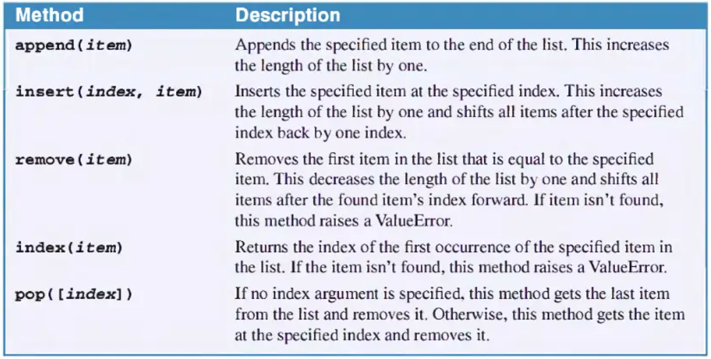

1. Open IDLE. Create a new file and save it as **list_methods**.py  
     
   Turn on **Line Numbering** by selecting **Options** then **Show Line Numbers**

Add the following to your file exactly as shown:

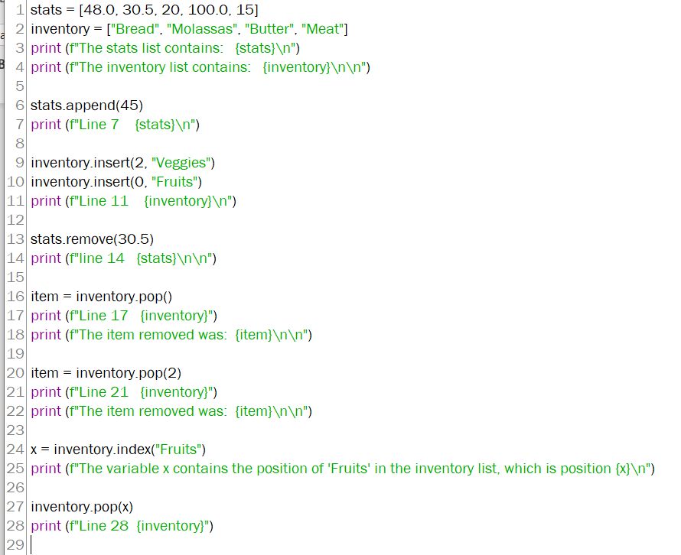

**Now run the code.**

1. When the print statement on line 7 is run, what is the output?

|  |
| --- |
| Line 7 [48.0, 30.5, 20, 100.0, 15, 45] |

1. What does **.append** do to the list?

|  |
| --- |
| Adds items to the end of a list |

1. When the print statement on line 11 is run, what is the output?

|  |
| --- |
| Line 11 ['Fruits', 'Bread', 'Molassas', 'Veggies', 'Butter', 'Meat'] |

1. What does **.insert** do to the list?

|  |
| --- |
| Inserts item at specified position |

1. When the print statement on line 14 is run, what is the output?

|  |
| --- |
| line 14 [48.0, 20, 100.0, 15, 45] |

1. What does **.remove** do to the list?

|  |
| --- |
| Removes specified item from list |

1. When the print statement on line 17 is run, what is the output?

|  |
| --- |
| Line 17 ['Fruits', 'Bread', 'Molasses', 'Veggies', 'Butter']  the item removed was: Meat |
|  |

1. What does **.pop()** do to the list?

|  |
| --- |
| Removes last item in the list and returns the value of the removed item |

1. When the print statement on line 21 is run, what is the output?

|  |
| --- |
| Line 21 ['Fruits', 'Bread', 'Veggies', 'Butter']  The item removed was: Molassas |

1. What does **.pop(2)** do to the list?

|  |
| --- |
| Removes the 2nd(3rd item starting at 0) and returns the value of that item |

1. What does **x = inventory.index("Fruits")** do?

|  |
| --- |
| Returns the position of the item “Fruits” |

1. When the print statement on line 28 is run, what is the output?

|  |
| --- |
| Line 28 ['Bread', 'Veggies', 'Butter'] |

1. What does **inventory.pop(x)** do to the list?

|  |
| --- |
| Removes the item in x position and returns the value |